Midwest Regional Bone Dysplasia Clinics
Richard M. Pauli, M.D., Ph.D., Director
August, 2007

Prevention of Fixed, Angular Kyphosis
in Achondroplasia
for physicians, orthotists and other health professionals

Introduction

Nearly all infants with achondroplasia develop a thoracolumbar junction kyphosis during the first year of life (Figures 1 & 2).

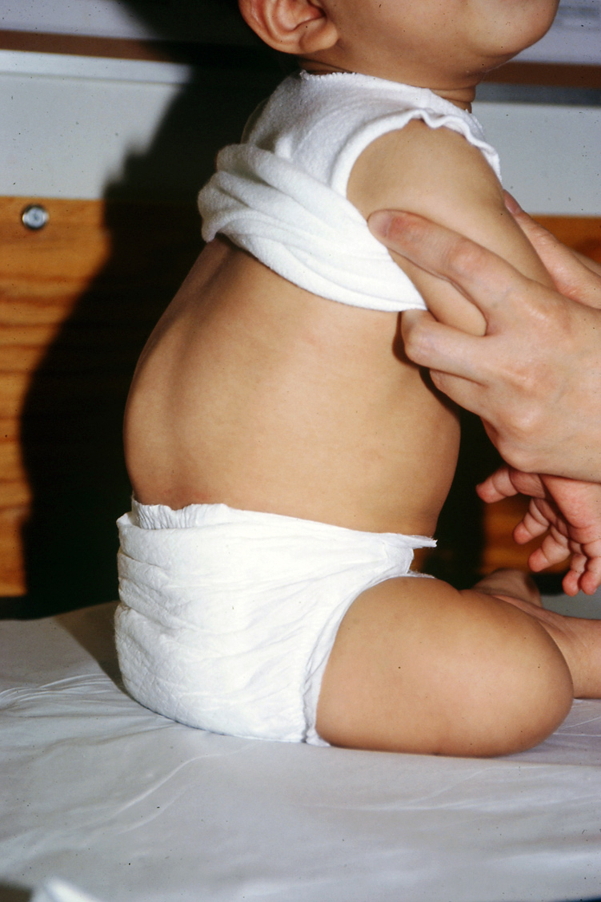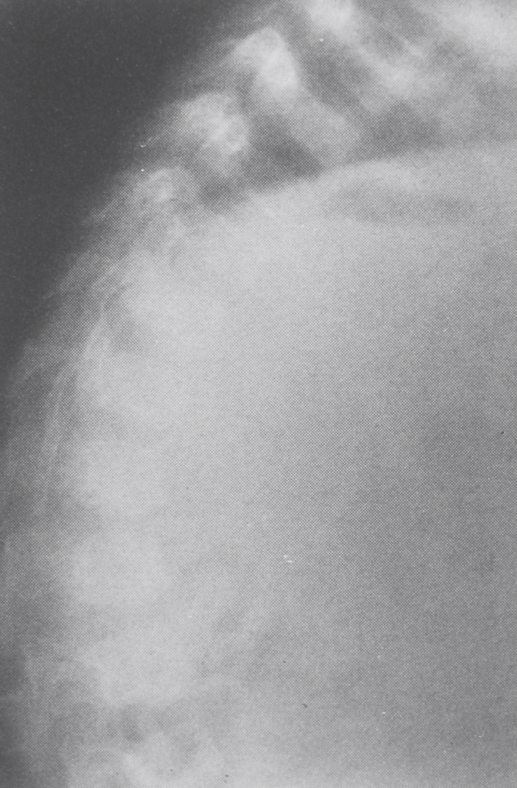
Figure 1: The dynamic and flexible Figure 2: Lateral radiograph of the spine.
kyphosis typically present in infants There is a smooth, non-angulated curve.
with achondroplasia if they are placed The vertebra at the apex of the kyphosis
in the sitting position. (arrow) is normal in shape, without
significant anterior loss of bone or wedging.

In 90% this spontaneously resolves without consequence. However, in around 10% a progressive kyphosis will arise. The development of wedging or beaking (Figure 3) indicates risk for persistence or progression of the kyphosis. Progression can then lead to a fixed, angular deformity (Figure 4).
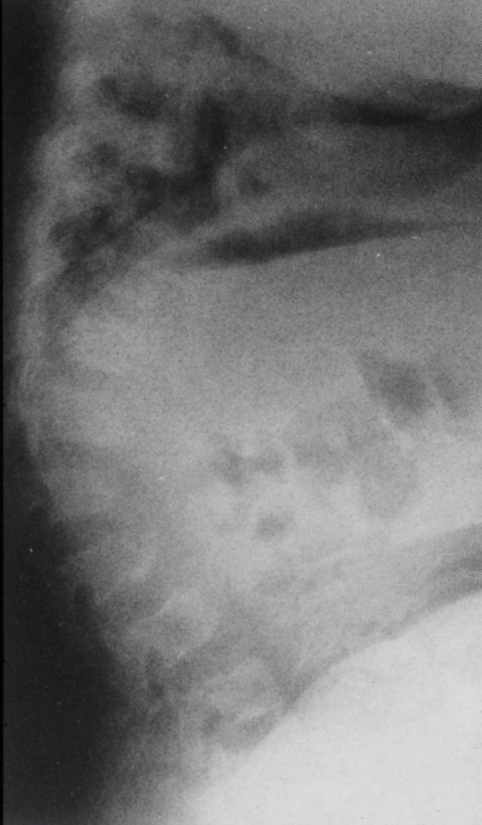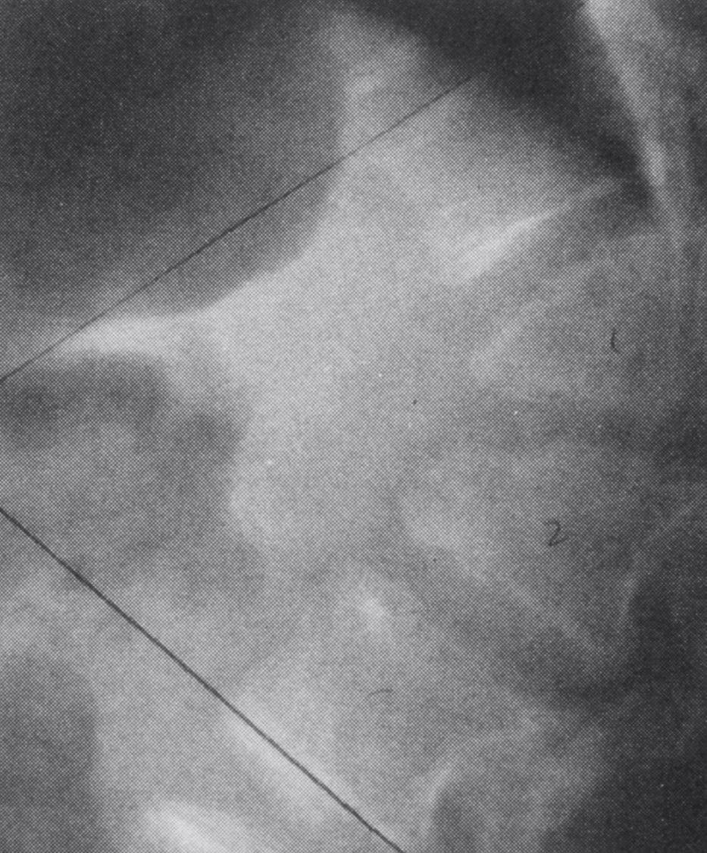
Figure 3: Lateral radiograph of the spine Figure 4: Lateral radiograph of the spine in an older child
showing early anterior wedging in whom severe wedging has developed (arrows) secondary
(arrows) indicative of the beginning to marked loss of bone from the anterior parts of affected
of a fixed kyphosis. vertebrae.

Mechanism and consequences

The kyphosis of achondroplasia is non-congenital and usually worsens in association with assuming a sitting posture. Why kyphosis develops and progresses appears to be explained by a combination of factors: truncal hypotonia; ligamentous laxity; a large head; intrinsically abnormal spine; gravitational force. The first three of these factors mean that if an infant with achondroplasia is placed in a sitting position, the infant will slump forward into a C-sitting posture. Gravity acting on intrinsically abnormal vertebrae over time can cause remodeling of the vertebrae resulting in deformity (loss of anterior body height and vertebral wedging (Figures 3 & 4). If a “breakpoint” (the point beyond which progression is physically inevitable) is exceeded, then further anterior compression results in an irreversible deformity.

Although almost always asymptomatic until adolescence, with ongoing growth the usual ‘ascent’ of the spinal cord is prevented by fixation of the cord at the apex of the kyphosis; with consequent cord damage, partial paralysis in the legs and/or bowel and bladder incontinence will develop in around ½ of those with severe, angular kyphosis.

Risks for neurologic consequences are so great that in those in whom a severe curve is present prophylactic spinal fusion surgery is generally recommended – usually in late childhood or in preadolescence. However the surgery is neither simple nor without risk for devastating complications. Therefore, strategies that reduce the likelihood for needing such surgery are desirable.

Behavioral interventions

There is substantial evidence that behavioral interventions can dramatically reduce the frequency of development of progressive kyphosis. First, unsupported sitting should be avoided at least for the first 12-15 months. The more hypotonic the infant, the more important is this intervention in prevention of development of a fixed kyphosis, and the longer this prohibition should be in force.

Furthermore, devices that place the child in the disadvantageous C-sitting position should be avoided. Examples include umbrella strollers and certain soft infant carriers. In addition, when the infant is held, good back support and gentle counterpressure – either with a hand or one’s body – at the point of the kyphosis is important (Figure 5).

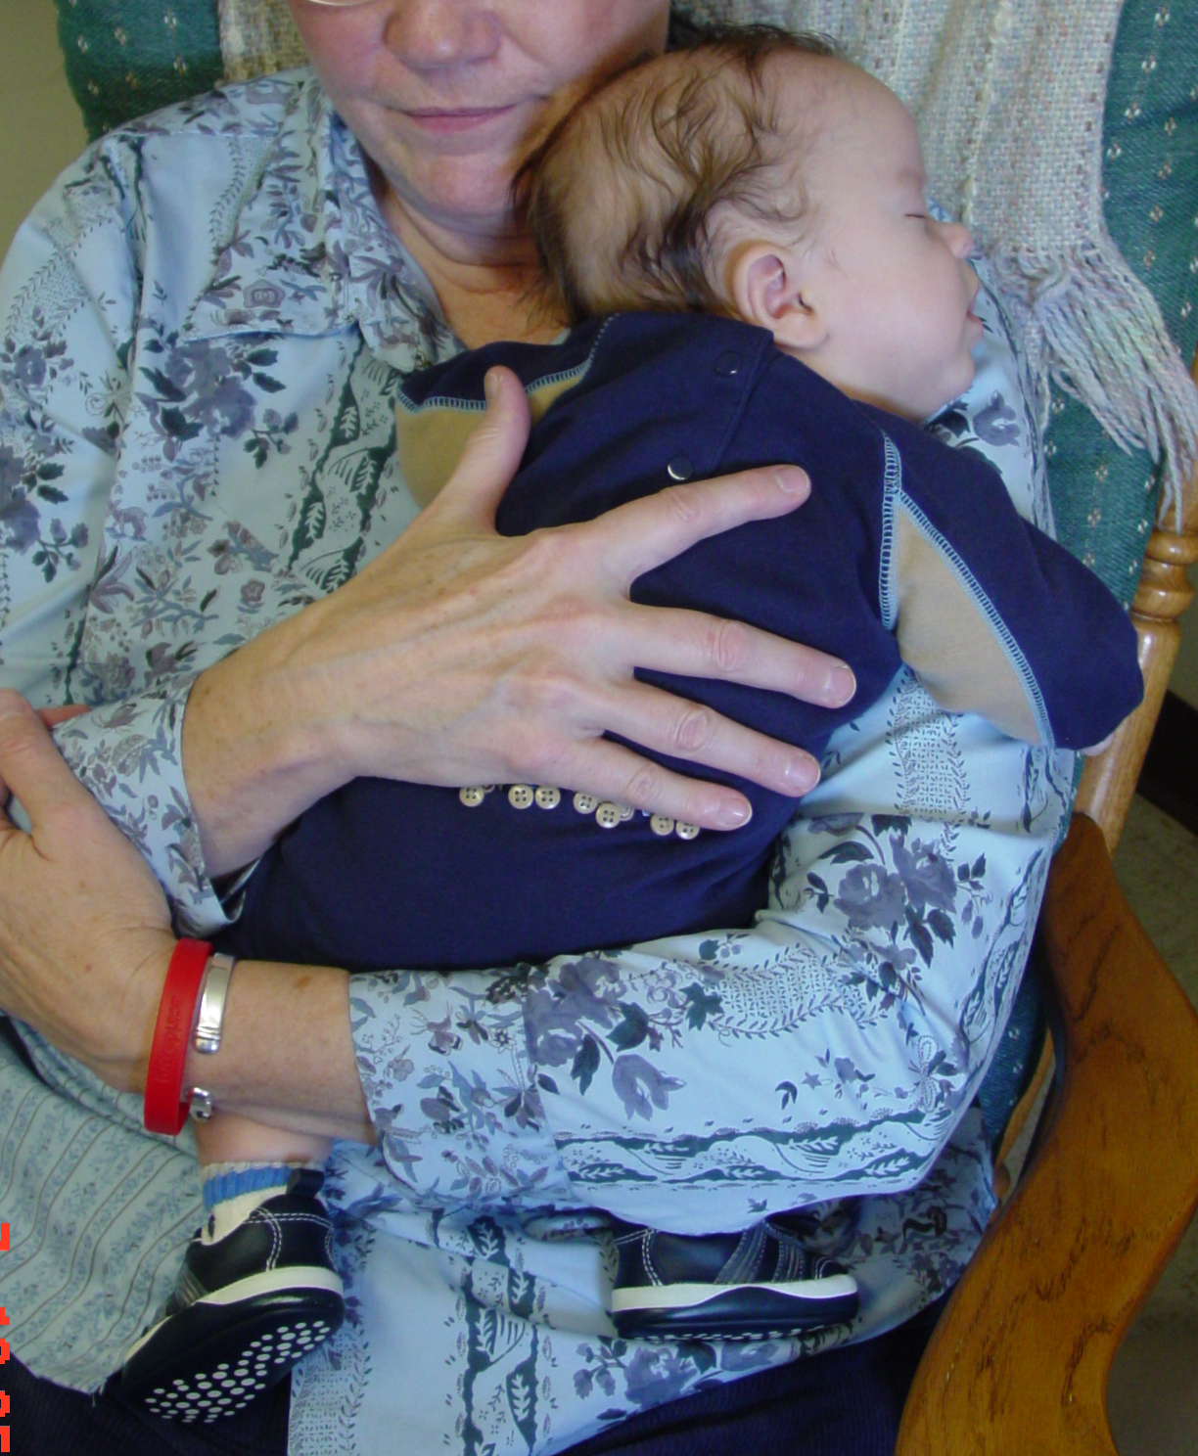 Figure 5: Gentle counterpressure with one’s hand over the site of the kyphosis while holding an infant with achondroplasia.

Prone positioning should be encouraged. This eliminates the dynamic kyphosis (Figure 6) and strengthens muscles needed to decrease C-sitting.

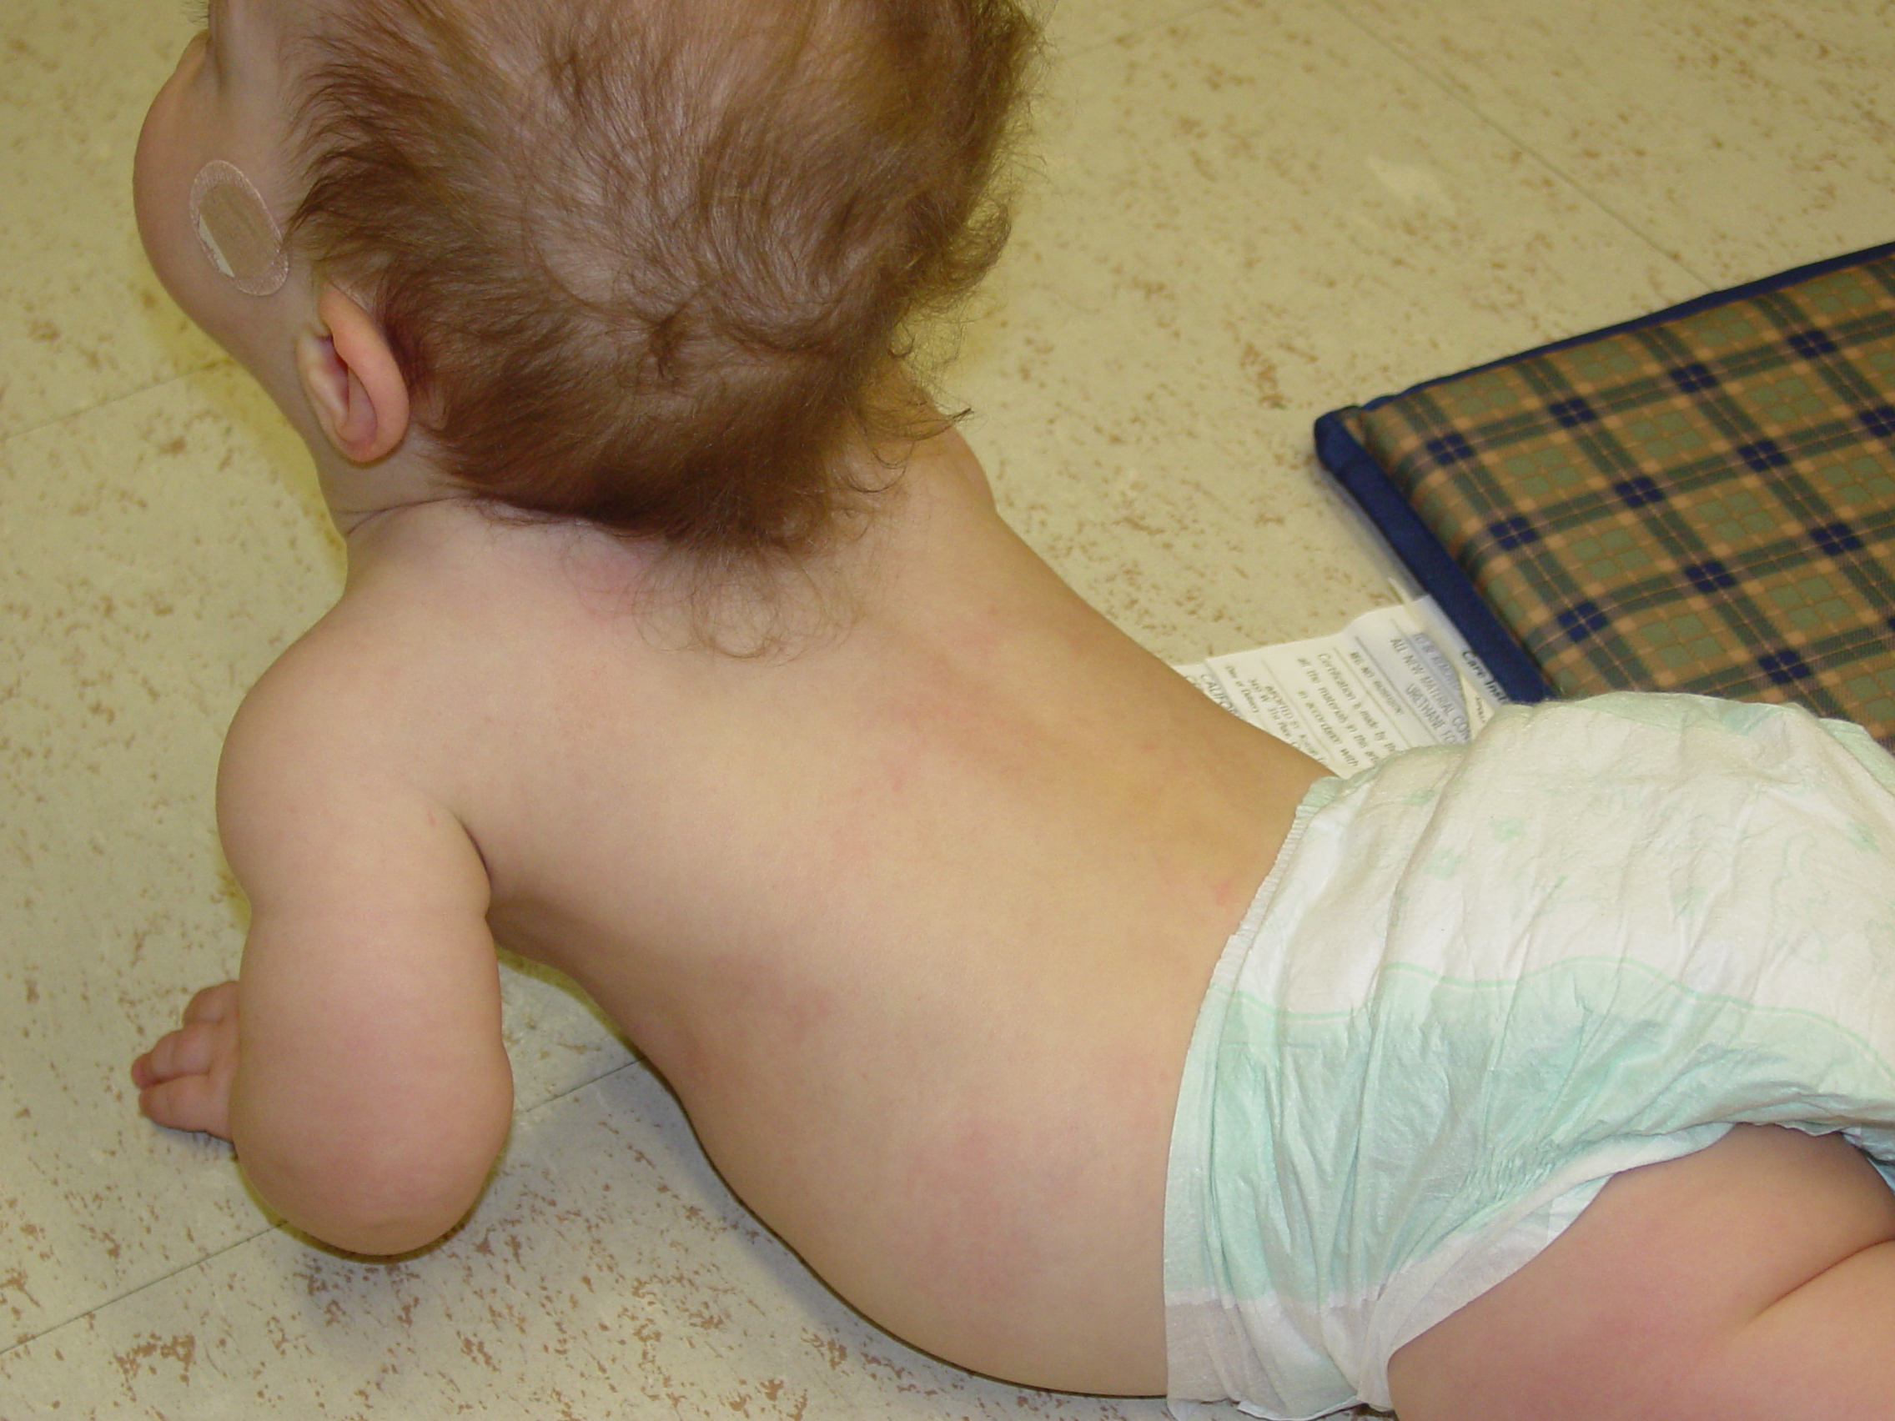
Figure 6: Prone positioning reverses the flexible kyphosis (arrow), strengthens lower back and abdominal muscles, and is an important part of prevention of fixed kyphosis.

Some children who resist ‘tummy time’ seem to do better if a narrow wedge is used under their head and upper chest.

Finally, one should check carrying and seating devices to make sure that there is good back support. Some infant carriers and car seats have padding that end just at the point of kyphosis, allowing unintended C-sitting without counterpressure. If that is the case, insertion of a foam extension to the padding is effective.

Behavioral intervention is sufficient to prevent a progressive, fixed kyphosis in around ¾ of infants with achondroplasia. Note that such interventions, including delaying of independent sitting appear to have no long term developmental consequences.

Indications for bracing

We have previously shown that in those in whom behavioral approaches fail, use of a brace can allow for correction of the kyphosis, re-growth of the lost bone substance and uniformly prevents the development of neurologic problems later on in life.

Therefore, if, despite counsel regarding prohibition of unsupported sitting, providing good back support, etc., a progressive curve seems to be developing then radiographs are obtained to quantify the severity of the kyphosis. Appropriate radiographs in infancy include a sitting lateral DLS spine and a cross-table prone DLS spine. The former documents the severity of the curve and the latter measures the irreversible component of that curve. (In particularly squirmy children who ‘inchworm’ when placed prone, thereby precluding reduction of the kyphosis, a cross-table supine DLS spine radiograph over a bolster may need to be substituted for the prone view.) If the following criteria are met, then we consider a child a candidate for bracing:
- An irreversible curve of greater than 30°;
- Significant loss of anterior vertebral body bony substance with vertebral wedging;
- More than trivial offset of one body compared with its adjacent members.

Rarely bracing is contraindicated. This may be the case in infants who have severe restrictive pulmonary disease secondary to a small chest and overly compliant ribs. In those, careful consideration needs to be given to the possibility that bracing will result in greater respiratory compromise.

Brace fabrication

The brace is a modified thoracolumbosacral orthosis (TLSO). Lots of alternative designs are effective, but in general all should have the following key characteristics:
- There must be a three-point pressure system (pressure adjacent to the kyphosis) and counterpressure at the chest and at the upper pelvis). This is most easily accomplished by using a solid half shell for the posterior part of the brace and a chest piece plus pelvic piece in front. (Figures 7 and 8)

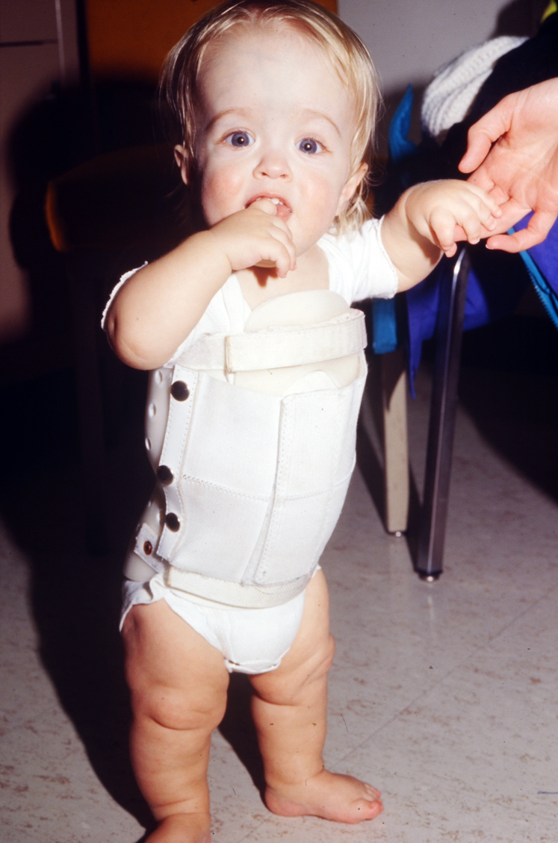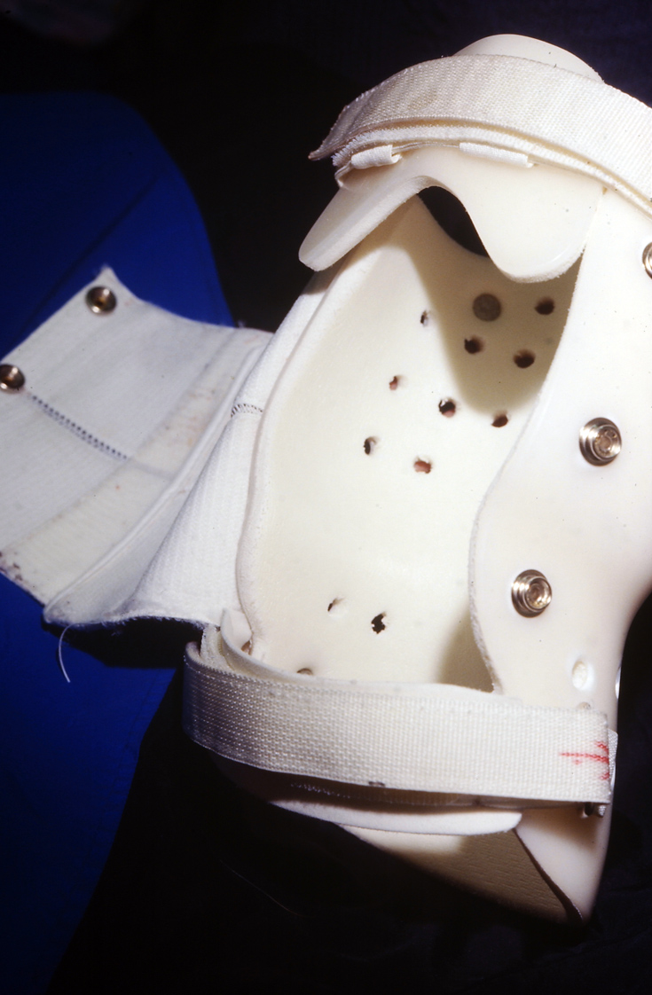
Figure 7: Young child with achondroplasia in a Figure 8: Modified TLSO brace. Note that a number of modified TLSO for kyphosis correction. variations to this design are just as effective – a
bivalved brace; a brace with a completely open belly
portion; etc.

- Posterior pressure should be on either side of the kyphosis (Figure 9). If directly overlying it, irritation and skin breakdown over the posterior elements is likely to occur.

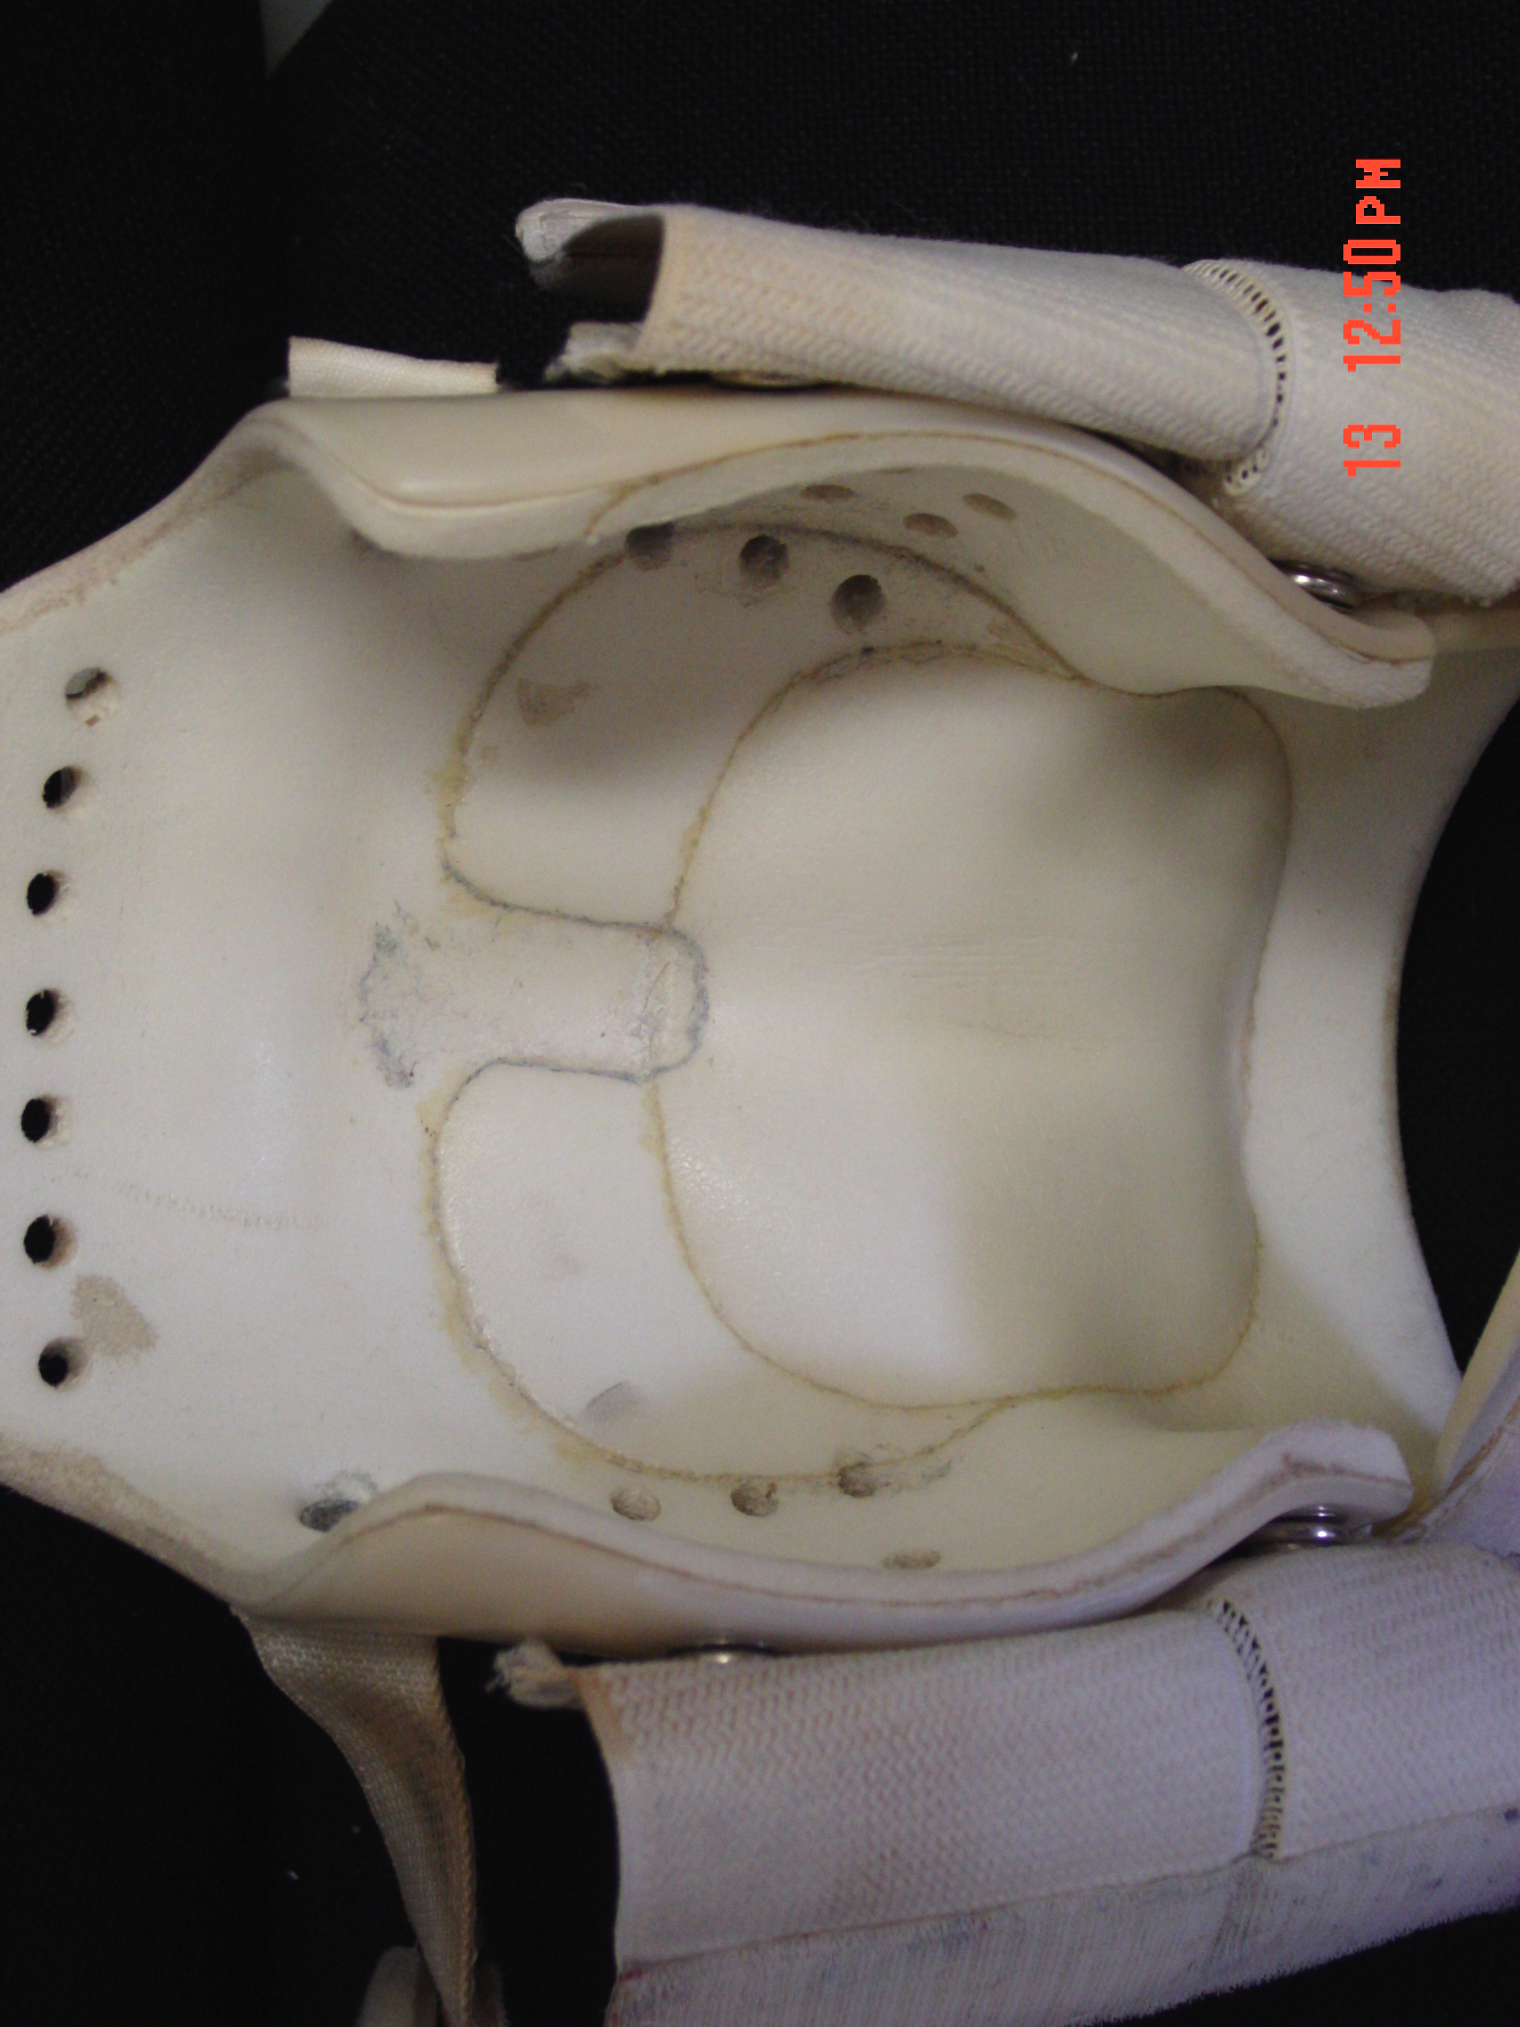

Figure 9: The interior of the brace showing build up on either side of the kyphotic apex. This pressure can be increased by sequentially adding padding without having to refit and fabricate an entire brace.

- Because children with achondroplasia have prominent abdomens and often have respiratory issues, too, it is usually better if the abdomen is left open (either using two separate pieces at the chest and pelvis or using a doughnut shaped anterior piece).

Common errors in brace fabrication that should be avoided include:
- Pressure directly over the kyphosis resulting in skin breakdown;
- Extension of the posterior ‘skirt’ too low so that the child can not sit comfortably, or a similarly too long anterior ‘skirt’ resulting in pinching and pain with hip flexion;
- Insufficient cut out at the axillae resulting in chafing with arm movement;
- Fasteners (Velcro or other forms) made too easily accessible to the toddler allowing for defeat of the purpose of the brace;
- Using insufficient counterpressure at the level of the kyphosis.

Brace fit and adequacy of counterpressure should be assessed by taking radiographs immediately after fitting of the fabricated brace, including sitting lateral out of brace and sitting lateral in brace. Correction of nearly all of the initial reversible component of the curve is the aim. So, for example, if sitting lateral kyphosis is 65° and prone kyphosis is 40°, then initial bracing should reduce the curve in brace to ~45-50°.

Brace use

The goal is 23 hour per day brace use (all times except bathing). (Alternatively, the brace can be used for all waking hours in children in whom the brace seems to be interfering with sleep or in whom nighttime breathing problems have been demonstrated previously.) Some children will require that the brace be loosened for a short time after meals, since in some either respiratory distress or worsening of reflux may occur in brace. Most children will adapt to the brace quickly and a long habituation is not needed – usually 23 hour per day bracing can be worked up to over 2-3 weeks.

End points of bracing

Bracing is clearly effective, but takes time. With appropriately aggressive care, the curve can be reversed and re-growth occurs usually within 6 to 24 months. In general bracing can be discontinued when:
- The maximal kyphotic curve is 20° or less (allowing a 10° margin of safety); and
- There has been re-ossification of most or all of the anterior portions of the involved vertebral bodies.

Monitoring during brace use

During brace use, the patient should be monitored as follows –
- The treating orthotist should see the child every 2-3 months (or whenever problems arise).
- Particularly early in bracing additional build up on either side of the kyphosis should be incorporated into the brace at each visit.
- A pediatric orthopedist or another physician with experience in caring for children with achondroplasia should reassess the child about every 6 months during bracing.
- In conjunction with those physician follow-up visits (and, as well, if problems seem to develop) radiographs should be obtained. What radiographs are most helpful depends on the developmental status of the child.
  - In children who are not yet stably independently sitting, 1.supported sitting lateral DLS in brace, 2. supported sitting lateral DLS out of brace and 3.cross table lateral prone DLS out of brace films should be obtained.
  - In children who are sitting independently but not yet standing on their own, radiographs should include 1.sitting lateral DLS in brace and 2.sitting lateral DLS out of brace.
  - In children who are standing independently, the radiographs should include 1.standing lateral DLS in brace and 2.standing lateral DLS out of brace.

Discontinuing bracing

When criteria listed above are met weaning from bracing can be completed. This should be slow enough to allow for strengthening of trunk support muscles but usually can be accomplished in 3-6 weeks. A typical weaning schedule would be –
- 15 minutes out of brace every 3 waking hours for one week and out of brace at night.
- 30 minutes out of brace every 3 waking hours for a second week (and out of brace at night).
- 60 minutes out of brace every 3 waking hours for a third week (and out of brace at night).
- 2 hours out of brace, 2 hours in brace etc. for a fourth week (and out of brace at night).
- Discontinuation of bracing.

Additional Resources

Trotter TL, Hall JG, American Academy of Pediatrics Committee on Genetics: Health supervision for children with achondroplasia. Pediatrics 116:1615, 2005.

Pauli RM, Breed AL, Horton VK, Glinski LP, Reiser CA: Prevention of fixed, angular kyphosis in achondroplasia. J pediatr orthop 17:726, 1997.

Questions and clarifications

Contacts:
Peggy Modaff, M.S.
Genetic Counselor
Clinical Genetics Center & Midwest Regional Bone Dysplasia Clinic
University of Wisconsin-Madison
modaff@waisman.wisc.edu

Catherine Reiser, M.S.
Genetic Counselor
Clinical Genetics Center & Midwest Regional Bone Dysplasia Clinic
University of Wisconsin-Madison
reiser@waisman.wisc.edu

Richard M. Pauli, M.D., Ph.D.
Professor, Pediatrics and Medical Genetics
Director, Midwest Regional Bone Dysplasia Clinic
University of Wisconsin-Madison
1500 Highland Avenue, #353
Madison, WI 53705

